**University of Engineering and Technology ,Taxila**

**Department of Computer Engineering**

# Lab Report 02

**For the Course of DBMS lab**

**Submitted By**:Muhammad Ibrahim (21-CP-26)

**Section:** Omega

## **Lab Instructor:**Sir Shahid Ali

**Course Instructor:**Engr.Sana Ziafat

**Date**: 20-01-24.

## **Course Title**: DBMS Lab

**SQL DML Commands**

**Examples:**

* **SELECT** - extracts data from a database
* **UPDATE** - updates data in a database
* **DELETE** - deletes data from a database
* **INSERT INTO** - inserts new data into a database

**Code:**

-- 21-cp-26 Examples Lab 2

Create database lab2

Create table Persons

( P_Id int,

Lastname varchar(255),

FirstName varchar(255),

Address varchar(255),

City varchar(255));

SELECT * from Persons

INSERT INTO Persons

VALUES(1,'Hansen','Christ','Timoteivn 10','Sandess');

INSERT INTO Persons(P_Id,Lastname,FirstName,Address,City)

VALUES(2,'Svendson','Tove','Borgvn 23','Sandess')

INSERT INTO Persons

VALUES(3,'Pettersen','Michael','Storgt_20','Stavanger');

INSERT INTO Persons

VALUES(4,'Nilsen','Johan','Bakken 2','Stavanger')

SELECT * from Persons

INSERT INTO Persons (P_Id,Lastname,Firstname)

VALUES (5,'Tjessem','Jakob')

UPDATE Persons

SET Address='Nissestien 67',City='Chicago',LastName='Micheal', FirstName='John'

WHERE P_Id=5

SELECT * from Persons

UPDATE Persons

SET Address='Nissestien 67',City='Sandness'

DELETE FROM Persons

WHERE LastName='Micheal' AND FirstName='John'

select * from Persons

SELECT LastName,FirstName From Persons

SELECT DISTINCT City,P_Id FROM PERSONS

select * from persons

where FirstName='Christ'

select * from persons

where FirstName='Tove'

AND LastName='Svendson'

select * from persons

where FirstName='Tove'

or LastName='Hansen'

SELECT * FROM Persons

ORDER BY LastName

SELECT * FROM Persons

ORDER BY LastName DESC

**Output:**

Some of the outputs

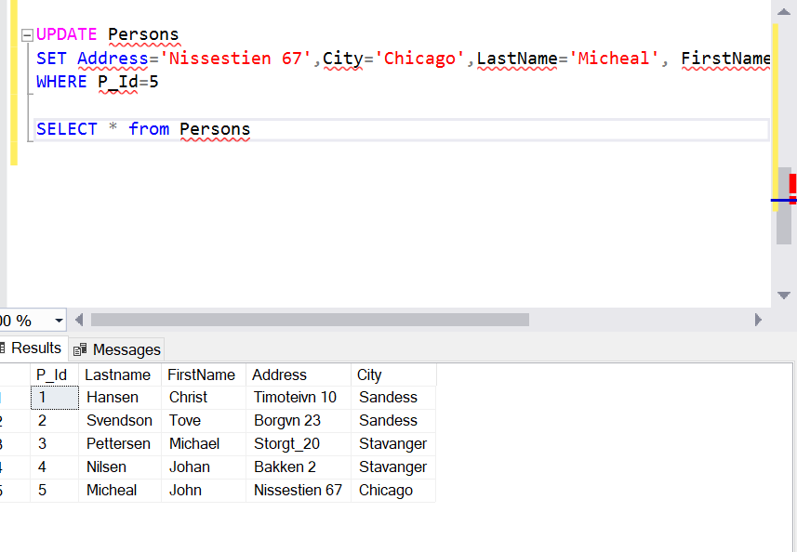

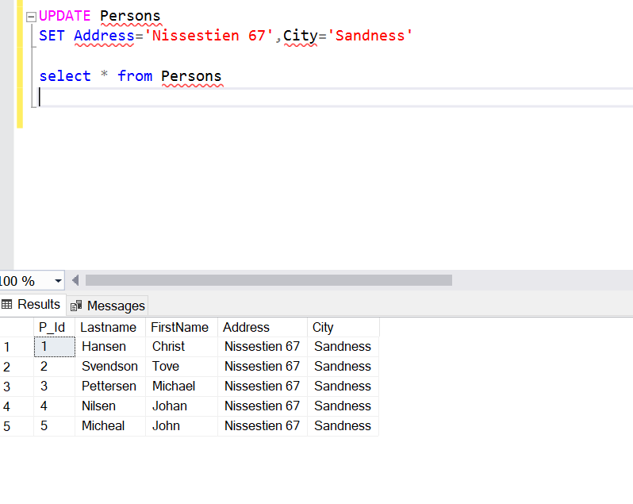 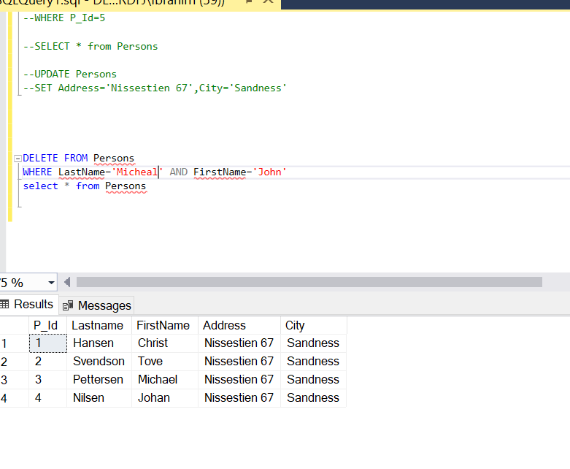

**Tasks**

**Task 1:**

Create the following table using SQL and using the INSERT INTO command, insert the following values in the table created.

|  |  |  |  |  |
| --- | --- | --- | --- | --- |
| **Name** | **Reg_No** | **Courses** | **Course_Code** | **Offered_By** |
| Ali | 01 | DIP | 1001 | Mr. A |
| Basit | 02 | DBMS | 1002 | Mr. X |
| Akram | 03 | OS | 1003 | Mr. Y |
| Asad | 04 | DBMS | 1002 | Mr. X |
| Zeeshan | 05 | DIP | 1001 | Mr. A |
| Muneer | 06 | OS | 1003 | Mr. Y |
| Shafqat | 07 | NM | 1004 | Mr. H |
| Ahsan | 08 | OS | 1003 | Mr. Y |
| Ikram | 09 | DIP |  |  |
| Hassan | 10 |  |  |  |

**Code:**

--21-cp-26 lab 1 task 1 create table

CREATE TABLE CP21

(

Name varchar(255),

Reg_No varchar(255),

Cources varchar(255),

Cource_Code varchar(255),

Offered_By varchar(255));

Insert INTO CP21(Name,Reg_No,Cources,Cource_Code,Offered_By)

VALUES('Ali','01','DIP','1001','Mr.A');

VALUES('Basit','02','DBMS','1002','Mr.X')

Insert INTO CP21

VALUES('Akram','03','OS','1003','Mr.Y')

Insert INTO CP21

VALUES('Asad','04','DBMS','1002','Mr.X')

Insert INTO CP21

VALUES('Zeeshan','05','DIP','1001','Mr.A')

Insert INTO CP21

VALUES('Muneer','06','OS','1003','Mr.Y')

Insert INTO CP21

VALUES('Shafqat','07','NM','1004','Mr.H')

Insert INTO CP21

VALUES('Ahsan','08','OS','1003','Mr.Y');

SELECT * FROM CP21

Insert INTO CP21(Name,Reg_No,Cources)

VALUES('Ikram','09','DIP');

SELECT * FROM CP21

Insert INTO CP21(Name,Reg_No)

VALUES('Hassan','10');

SELECT * FROM CP21

**Output:**

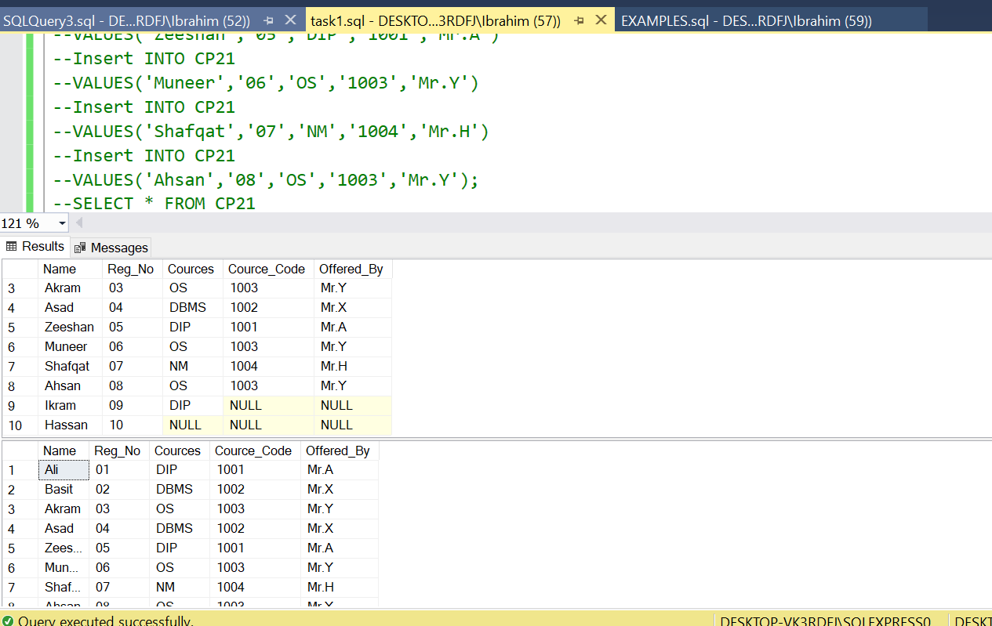

**Task 2:**

Using the UPDATE statement, update the above table for the following values:

|  |  |  |  |  |
| --- | --- | --- | --- | --- |
| **Name** | **Reg_No** | **Courses** | **Course_Code** | **Offered_By** |
| Ali | 01 | DIP | 1001 | Mr. A |
| Basit | 02 | DBMS | 1002 | Mr. X |
| Akram | 03 | OS | 1003 | Mr. Y |
| Asad | 04 | DBMS | 1002 | Mr. X |
| Zeeshan | 05 | DIP | 1001 | Mr. A |
| Muneer | 06 | OS | 1003 | Mr. Y |
| Shafqat | 07 | NM | 1004 | Mr. H |
| Ahsan | 08 | OS | 1003 | Mr. Y |
| Ikram | 09 | DIP | 1001 | Mr. A |
| Hassan | 10 | DSP | 1005 | Mr. Z |

**Code:**

UPDATE CP21

SET Cource_Code='1001',Offered_By='Mr.A'

WHERE Reg_No='09'

UPDATE CP21

SET Cource_Code='1001',Offered_By='Mr.A',Cources='DSP'

WHERE Reg_No='10'

SELECT * FROM CP21

**Output:**

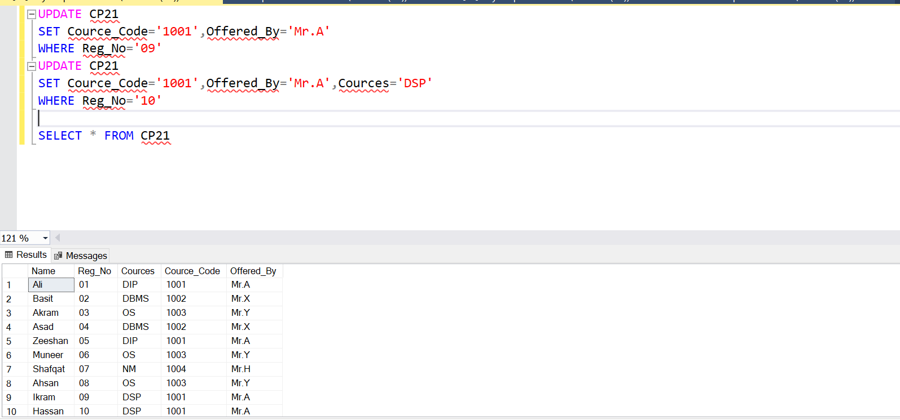

**Task 3:**

Using the DELETE statement, delete the record for the student having name Akram and Ahsan in the above table. Also delete the record for the course having course code=1001.

**Code:**

Delete FROM CP21

WHERE Name='Ahsan' or Name='Akram' or Cource_Code='1001'

SELECT * FROM CP21

**Output:**

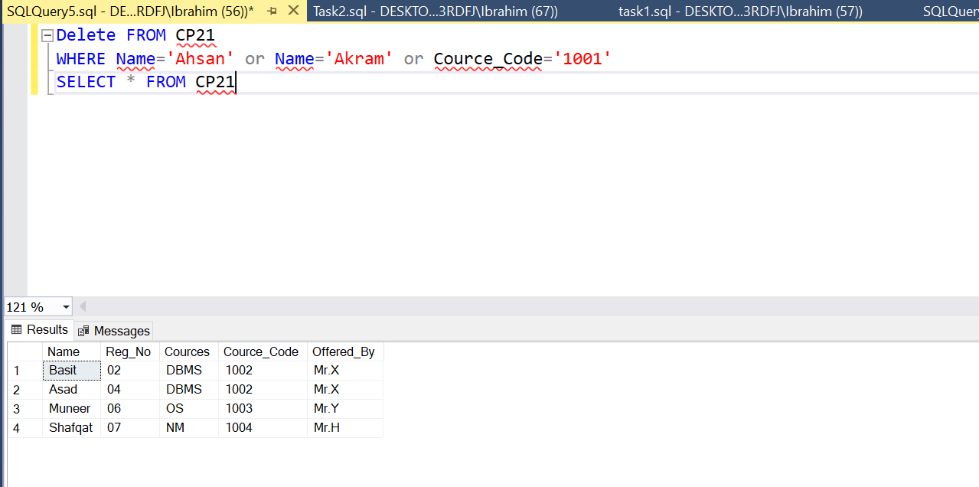

**Task 4:**

Select distinct values from the above table for the last three columns.

**Code:**

SELECT DISTINCT Cources,Cource_Code,Offered_By FROM CP21

**Output:**

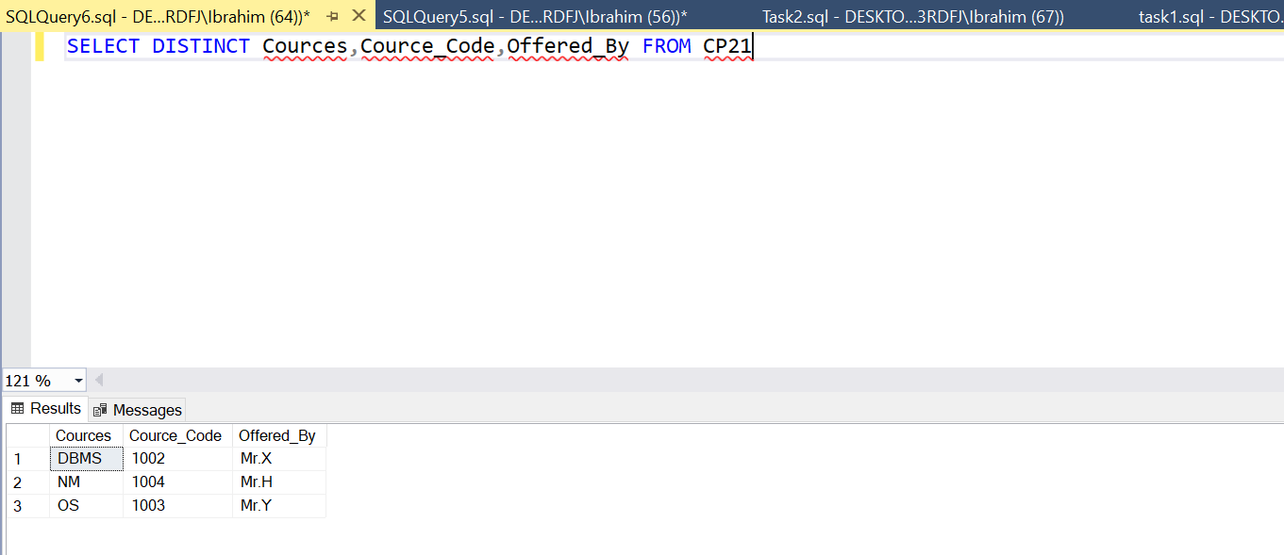

**Task 5:**

Sort the above table in descending order by their name.

**Code:**

SELECT *

FROM CP21

ORDER BY Name DESC;

**Output:**

